|  |
| --- |
| S1閥桿手動 ( S1 stem manual ) |
| 閥桿定位( Stem positioning) |
| 閥桿壓入( Stem press) |
| 閥桿頂起( Stem jacking up) |
| 送閥桿(Feeding stem) |
| 手動選擇( Manual selection) |

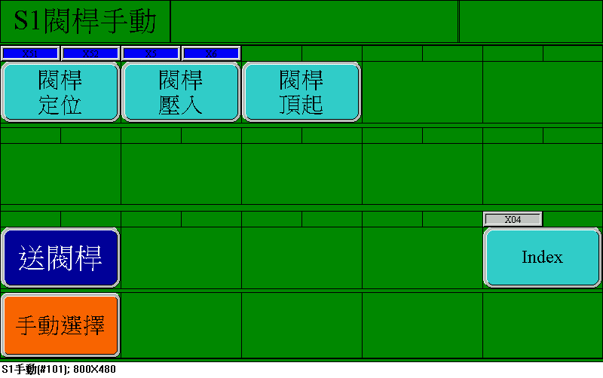

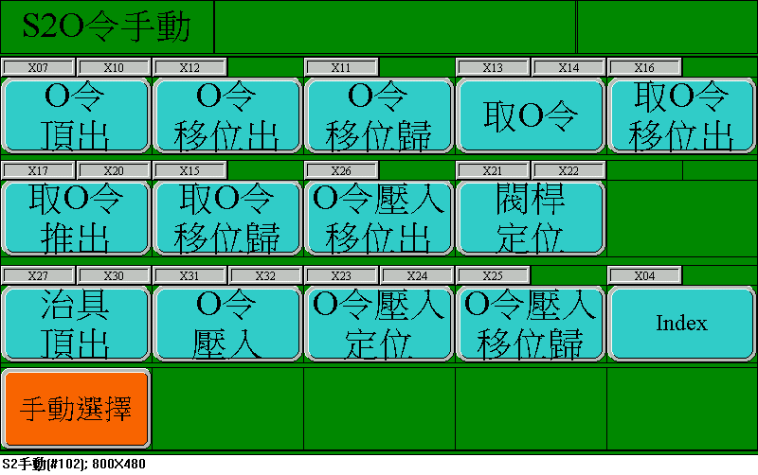

|  |
| --- |
| S2 O-ring手動 ( S2 O-ring manual ) |
| O-ring頂出(O-ring ejection) |
| O-ring移位出(O-ring moving out) |
| O-ring移位歸(O-ring moving back) |
| 取O-ring(Taking O-ring) |
| 取O-ring 移位出(Take O-ring- moving out) |
| 取O-ring 推出(Take O-ring- pushing) |
| 取O-ring 移位歸(Take O-ring- moving back) |
| O-ring壓入移位出(O-ring press moving out) |
| 閥桿定位 (Stem positioning) |
| 治具頂出(Jig ejection) |
| O-ring壓入(O-ring press) |
| O-ring壓入定位(O-ring press positioning) |
| O-ring壓入移位歸(O-ring press moving back) |
| 手動選擇(Manual selection) |

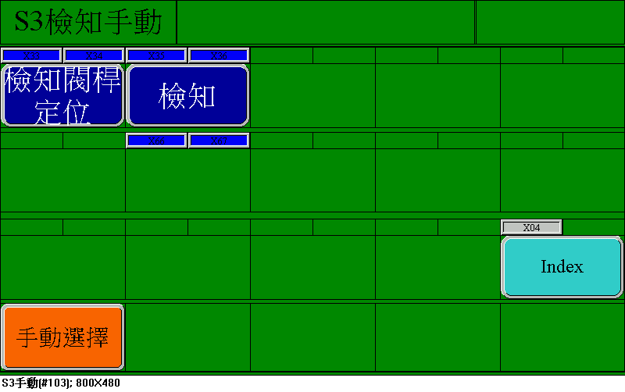

|  |
| --- |
| S3檢知手動 ( S3 Detection manual ) |
| 檢知閥桿定位( Stem positioning detection) |
| 檢知(Detection) |
| 手動選擇( Manual selection) |

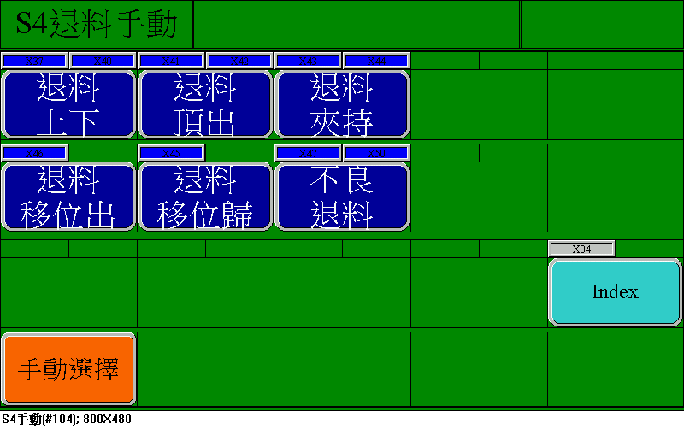

|  |
| --- |
| S4退料手動 ( S4 Unloading manual) |
| 退料上下( Unloading up/down) |
| 退料頂出(Unloading ejection) |
| 退料夾持(Unloading clamp) |
| 退料移位出(Unloading move out) |
| 退料移位歸(Unloading move back) |
| 不良品退料(Unloading NG product) |
| 手動選擇( Manual selection) |